**File Creation Task**

1. Create a directory called ""my_folder"", navigate into it, and create a file named ""my_file.txt"" with some text. Then, create another file named ""another_file.txt"" with some text. Concatenate the content of ""another_file.txt"" to ""my_file.txt"" and display the updated content. Finally
   1. **mkdir my_folder**

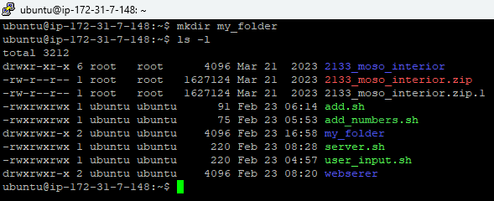

* 1. **cd my_folder**

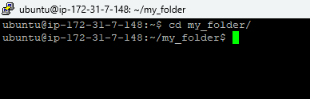

* 1. **nano my_file.txt**

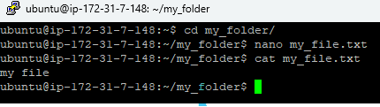

* 1. **nano another_file.txt**

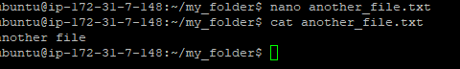

* 1. **cat another_file.txt >> my_file.txt**
  2. **cat my_file.txt**

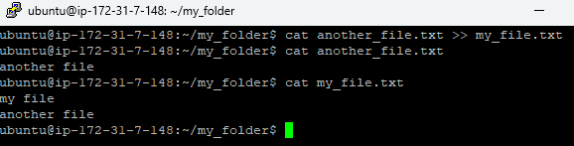

1. Create 20 files with .txt extensions and rename the first 5 files to .yml extension and Print the latest created top 5 files among the total no of files".
   1. **touch file{1..20}.txt**

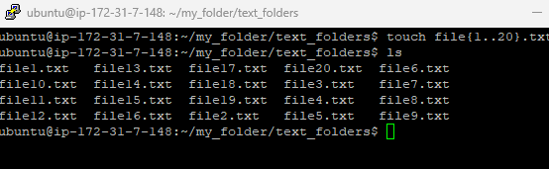

* 1. **mv file1.txt file1.yml**

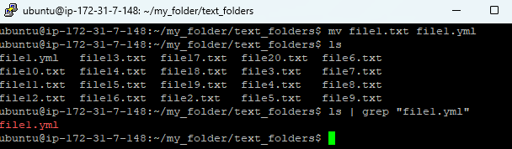

* 1. **mv file2.txt file2.yml**
  2. **mv file3.txt file3.yml**
  3. **mv file4.txt file4.yml**
  4. **mv file5.txt file5.yml**

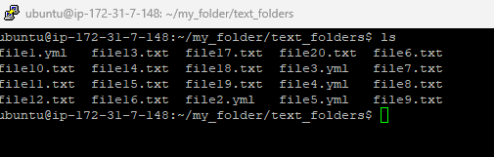

* 1. **ls -t | head -n 5**

